For example,

* Alpha=0.05 will a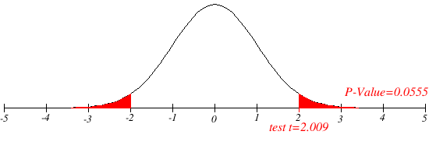ccept both the hypothesis.

* And alpha=0.8088 would reject both of the hypothesis.

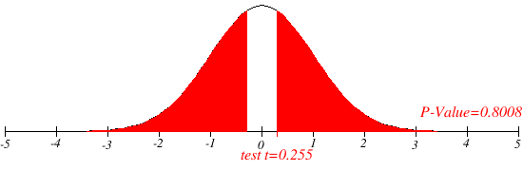

* Here, the domain knowledge can be a deciding factor if we know about, this bit rates a priori.